**Chapter ­-2**

**Mathematical model generalized electrical machine with the nourishment from the inverter in the 3- phase coordinate systems**

**2.1. Mathematical model of the idealized three phase generalized machine**

Usually study by 3m both analytical, and numerical in the majority of the cases is based on the basis of two phase rectangular coordinate system.

Digital simulation makes it possible to manage without the introduction of artificial coordinates, the equations, which describe behavior 3m can be written down in the natural axes – of those connected with the phases of stator-rotor unit. Convenience in this record of the system of differential equations consists of the following, with work 3m from the converter for the correct description of the operating mode it is necessary to constantly convert the temporary dependences of voltage, currents and fluxes linkage to the artificial rectangular axes; therefore is lost direct information about the currents in the phases of stator-rotor unit. However, in the three-phase system we deal concerning the real phase current strengths.

Let us examine the system of differential equations 3m in the untransformed phase axes. For this purpose let us examine the idealized model of electrical machine (3m) with magneto connected three-phase circuit (fig.1.3). If it is examined by induction motor with the cage rotor, then  phases are locked on the rotor.

The majority of the electrical machines of alternating current is intended for the work in the three-phase networks; therefore they are constructed with the symmetrical three-phase windings on the stator; moreover MMF of these windings are distributed in the space according to the law close k

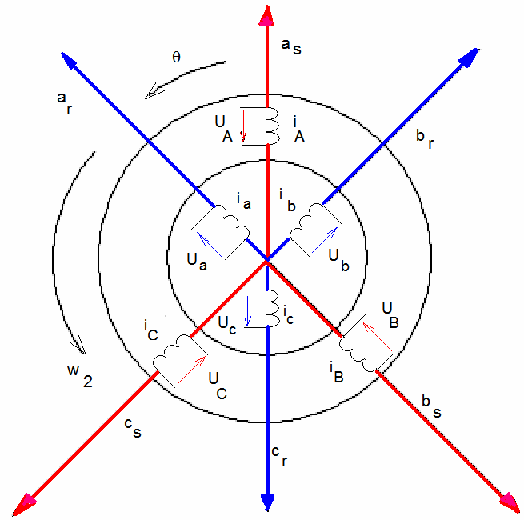

Fig.(1.3) idealized model 3 - the phase generalized electrical machine of the vector model of induction motor

Sinusoidal i.e. MMF, created k -1 by winding at the point, which is distant behind the axis to this winding to the angle  is equal -, where - MMF, which corresponds to axis k -1 of winding. *The sinusoidal character of distribution makes it possible to present MMF or proportional to them currents by the generalized three-dimensional vector on the complex plane*, i.e., by the vector, which is the vector sum of the sections, built on the three-dimensional axes of phase windings and which correspond to the instantaneous values of phase MMF or currents. In this case the projections of the generalized vector on the axis of phase windings at any moment of time will correspond to the instantaneous values of the corresponding values.

In the symmetrical three-phase system of windings the generalized vector of the armature current and rotor can be represented in the form,

 (2.1) (for the stator)

 (2.2) (for the rotor)

Where  - the operators of the rotation

Where - the instantaneous values of the currents of the corresponding stator windings

- The instantaneous values of the currents of the corresponding rotor windings

*Kirchhoff's equations*

 the equation of primary voltage in vector form (2.3)

 the equation of the voltage of rotor in vector form (2.4)

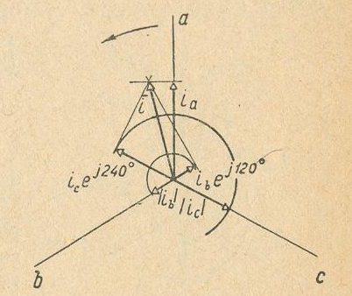

Fig (1.4) the vectors of the currents of three phases

   (2.5)

The generalized vector as any vector on the complex plane can be represented by the algebraic form of the record of the complex number. Usually this is made, combining material axis with the axis of winding **A** for the stator and windings and for the rotor (fig 1.4), then

*Phase armature currents1*

 (2.6)

 (2.7)

 (2.8)

We analogously obtain the phase currents of the rotor

 (2.9)

 (2.10)

 (2.11)

*Flux linkage*

























  

  

  













 in the matrix formula



it is possible to rewrite



where,

  

  





the given matrix

  

   













 

 

it is possible to rewrite







7





















 (2.43)

 (2.44)

 (2.45)

 (2.46)

*EMF of the transformation*

 (2.47)

*Given of the flux linkage*

 (2.48)

*EMF of the rotation*

 (2.49)

 (2.50)

Kirchhoff's equations for the phase primary voltages and rotor 3m



 (2.51)



in the matrix formula

 (2.52)

Internal torque

  (2.53)

If rotor revolves with the variable angular velocity, then its motion is described by equation

 (2.54)

Where J - total moment of the inertia of rotor and load mechanism of p - number of pole pairs;  - moment of resistance

  

  

 (2.55)

*Kirchhoff's equations*

 (2.56)

 (2.57)

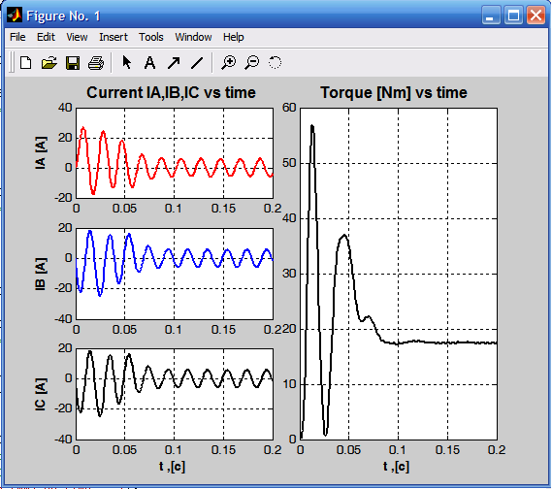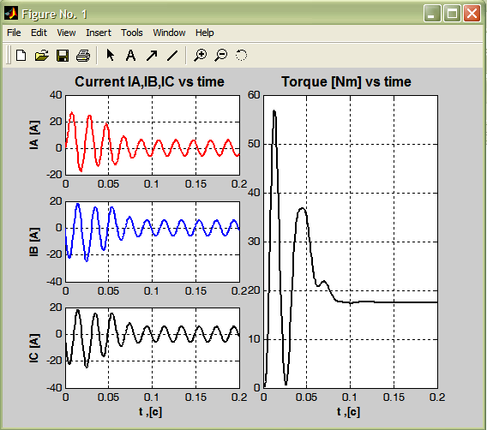

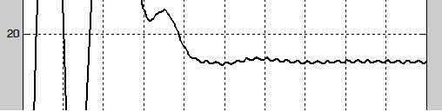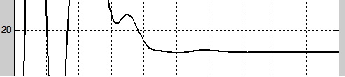

(a) of (b)

Fig (2.5) the solution OF SDU AD (a) without AIN of (b) with AIN

**2.5. Vector model of induction motor taking into account the null sequence**

If the stator of machine has neutral conductor, then phase currents can contain zero component and their values it is possible to represent in the form, and. Then the vector of current is equal

 (2.58)

  (2.59)

Kirchhoff's equations for the phase primary voltages AD

 (2.60)

 (2.61)

 (2.62)

Kirchhoff's equations for the phase voltages of rotor 3m



 (2.63)



Thus, the generalized vector of armature current does not contain zero components and it during the analysis should be considered separately. If phase currents contain zero component, then its value will be equal  or. For phase of the value of armature currents, either  and for phase of the value of the currents of rotor, or. In the phases of stator-rotor unit, the current of null sequence is created correspondingly TO EMF.

For the symmetrical regimes, and also in the absence neutral particles in star or connection of the windings by triangle in the system of equations (2.60-2.63), current  it is excluded. [ 14 ]

**2.6. Mathematical model of electrical machines taking into account saturation in the phase coordinate system with the stagnation rotor**

The differential equations of the saturated electrical machine take the same form as for the unsaturated machine.

For the coordinate system  the equation of the outlines of stator taking into account losses in steel 

 (2.64)

Equations of the outlines of the short-circuited rotor

 (2.65)

For the flux linkage and the currents are valid the following expressions:

 (2.66)

 (2.67)

 (2.68)

 (2.69)

 (2.70)

The projections of the vector of the magnetizing current on  the coordinate axes will examine:

 (2.71)

We differentiate on time (2.71)

 (2.72)

For the derived flux linkage in (2.72) it is correct

 (2.73)

Derivative of the current of the magnetization

 (2.74)

Expression (2.66) we substitute in (2.72). In the obtained expressions the parameters, inversely proportional to static and dynamic inductances, let us designate, correspondingly, through  and.

  (2.75)

As a result we obtain

 (2.76)

Where 

  

 (2.77)

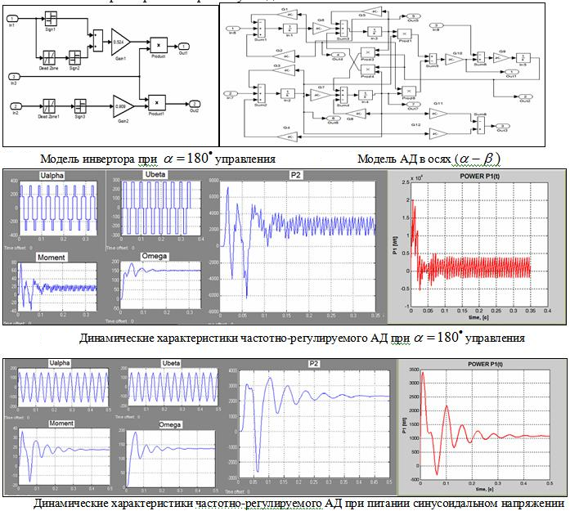

Fig (2.6)

During the solution of the system of the differential equations, which describe the work of system PCh- hell, is used Runge-Kutta method in the modification of Geer. The system of linear algebraic equations, utilized during the calculation of the parameters AD taking into account of saturation and current displacement, is solved in the matrix form by the method Of sarriusa.

**2.7 mathematical model of induction motor with the short-circuited rotor in the system of coordinates a.b.ch, fixed relative to stator and, rotor, taking into account loss in steel**

In the general case short-circuited rotor is represented in the form the m- phase system of windings. During the composition of differential equations the rotor winding can be replaced with two short-circuited equivalent outlines fixed relative to stator, arranged along the mutually perpendicular axes.

For the most precise description of the processes of electromechanical conversion we will use a model AD with three stator windings, arranged symmetrically in the space along axes a.b.ch and by two rotor windings, arranged along the mutually perpendicular axes, (fig).For positive direction of flow in the windings of the idealized machine let us accept direction from the end of the coil to its beginning, while for the positive direction of the axis of winding - the direction of the vectors MMF of coils during the flow of currents in the positive direction.

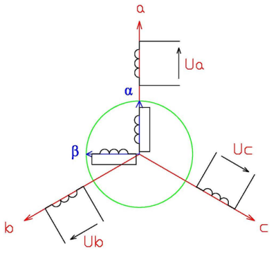

Fig(1.7). Schematic of the model of three-phase induction motor in the system (a.b.ch, (******))

The importance of the task of the calculation of losses in steel at least with the work AD with the loads, which do not exceed nominal, is determined by the significant contribution of these losses to the summary losses of machine. Thus, for AD of a series of в losses in steel can comprise more than 20% of the total losses of nominal rating and more than 50% of the complete no-load losses. Not the calculation of these losses during the analysis of the energy characteristics of drive leads to the essential errors. A small effect of loss in steel is had also for the value and the mutual orientation of the generalized vectors of the electromagnetic variables OF AD (voltage, currents, and flux linkage) in the static and dynamic behaviors of work.

In the present work to this work the effect from the losses in steel is investigated by the development of two versions of mathematical model AD on the basis of T-shaped equivalent circuits:

* with the series connection of the effective resistance of equivalent to losses in steel –Rm and inductive reactance of magnetization - The xm (ris.2 8,a).
* with the parallel connection of the resistances of the magnetizing outline Rc and The xm (fig 2 8,b).

Resistances Rc and The xm can be easily calculated on the known resistances of Rm, The xm according to the expressions

 , (2.78 1)

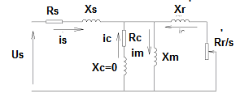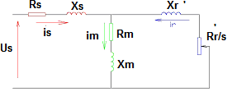

A) b)

Fig 2. 8. Equivalent circuits AD taking into account loss in steel

A) With the series connection of resistances of Rm and The xm, b) with the parallel connection of resistances of Rc and The xm.

It is known [for 10 ] that resistance Rm depends not linearly on the frequency of the reversal of polarity of magnetic circuit f, namely. Then Rm can be expressed as, where - the resistance of losses in steel, calculated at the frequency –. Resistance Rc, according to expression (2.78) will also not linearly depend on frequency, but differently to law, then. Graphs of a change in resistances of Rm and R c in the dependence on the frequency are represented in fig. 2.9.

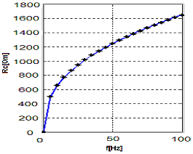 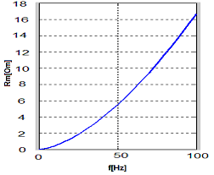

Fig (2. 9) dependences resistance, from the frequency

**2.8 mathematical model AD taking into account losses in steel without the influence the outlines of the eddy currents**

In the first version of model it is investigated processes by the introduction of the equivalent effective resistance of losses in steel  directly into the system of differential equations, that corresponds T - to reverse equivalent circuit for steady-load conditions, which is depicted on fig 2,a. The equations for this case, written down in the vector form in the fixed coordinate system, take the form:

 - equation for the primary voltages (2.79 2)

 - equation for the voltagees of rotor (2.80 3)

- equation for the armature currents and rotor (2.81 4)

equation for internal torque (2.82 5)

Here, the generalized vector of primary voltage, the generalized vector of the voltage of rotor, equivalent effective resistance eddy currents, the generalized vector of the flux linkage of stator, the generalized vector of the flux linkage of rotor. - the generalized vector of magnetizing current, p - the number of pole pairs, internal torque of engine, nm.

In the symmetrical three-phase system of windings and absence of neutral conductor those generalized of the vector of the armature currents, rotor  and magnetization  can be represented in the form :

 for the armature current, (2.83 6)

 for the current of rotor. (2.84 7)

 for the current of magnetization (2.85 8)

where, the operators of the rotation

where - the instantaneous values of the currents of proper phases of the stator

- the instantaneous values of the currents of proper phases of the rotor

- the instantaneous values of the currents of the magnetization of proper phases

The generalized vector as any vector on the complex plane, can be represented by the algebraic form of the record of the complex number.

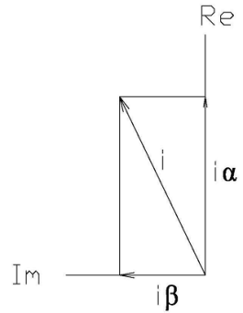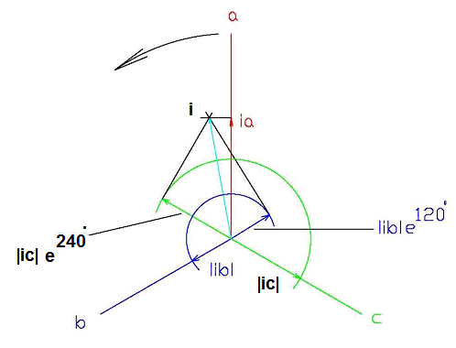

(a) of (b)

Fig (2.10) Vectors of the currents of three phases (a) and two phases of (b)

Usually this is made, combining material axis with the axis of phase **A**  of stator and phase **and**  of rotor, then phase armature currents to the system of coordinates (but, b.ch (Fig. 2.10,a) and the phase currents of rotor in the system coordinates (**) (**fig. 2.10,b) take the form:

*Phase armature currents in the system of coordinates (a.b.ch)*

 (2.86 9)

 (2.87 10)

 (2.88 11)

*Phase currents of rotor in the coordinate system *

,  (2.89 12) here, phase armature currents 3- phase AD, the armature currents and rotor in system a.b.ch, (******), the effective resistance of the phase of stator-rotor unit, Rm - effective resistance, equivalent to losses in steel.

The system of differential equations for the instantaneous values obtained on the basis of equations (2) -(3), taking into account (9) -(12) takes the following form:

*Equations of the primary voltages and rotor*

 (2.90 13)

Here, it is marked

  (2.91 14) *the equations of internal torque*

 (2.92 13)

*Equations of motion*

 (2.93 15)

where J - total moment of the inertia of rotor and mechanism, led to the shaft AD,  moment of resistance

*Equations for the flux linkage*

The expressions of flux linkage, written down through the currents in the stagnation system of coordinate’s a.b.ch , take the following form

 (2.94 16)

where - armature currents and rotor, A, - flux linkage of the phases of stator (rotor), Wb.

This system makes it possible to analyze work AD taking into account loss in steel in the case of its work from the frequency converter, when non sinusoidal voltage is supplied to the windings of engine.

**2. 9 mathematical model for the investigation of the transient processes of AD taking into account loss in steel in system a.b.ch, () upon the parallel connection of resistances of Rc and the xm (fig 2,b)**

To this mathematical model corresponds the diagram of the layout of the phases of stator-rotor unit and outlines of eddy currents as shown in ris.shch. This model, in contrast to that examined above, has 3- outline along axes a.b.ch the considering losses in steel.

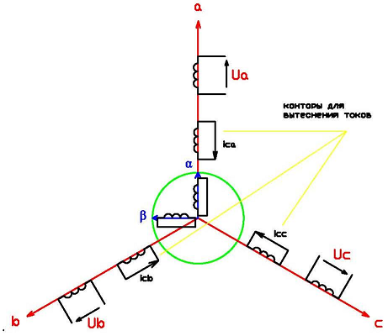

Fig(1.11). Schematic of model AD in the system (a.b.ch, (******)) taking into account the outlines of the eddy currents

The system of differential equations to vector form takes the form

; - the equation of primary voltages (2.95 16)

; - the equation of the voltages of rotor (2.96 17)

; - the equation of voltages the outlines of eddy currents (2.97 18)

 - equation for the flux linkage of stator (2.98 19)

 - equation for the flux linkage of rotor (2.99 20)

 - equation for the flux linkage the outlines of eddy currents (2.100 21)

 - equation for the flux linkage of vzaimoinduktsii(2.101 22)

 - the equation of currents (2.102 23)

Spreading the vectors of the system of differential equations (16-23) for the axes (a.b,s) and () we will obtain the system, written down in the scalar form, which takes the form

   (2.103 24)

  . (2.104 25)

  (2.105 26)

 (2.106 27)

 (2.107 28)

*Equations for the currents and the flux linkage*

 (2.108 29)

 (2.109 30)

 (2.110 31)

(2.111 32) where - phase eddy currents, A.

**2. 10 study of the influence of current displacement on the dynamics of frequency- adjustable induction motor**

The phenomenon of current displacement in the rods of the rotor winding has a significant effect on dispersal AD as is known, during the launching in the rods of rotor the significant eddy currents, which change the distribution of current density over the section of the rod of rotor, appear. As a result the effective resistance increases, and inductive reactance - decreases. An increase in the effective resistance and the decrease of inductive starting resistance because of current displacement affect dynamic characteristics AD (to impact and starting torques, starting current, starting time, etc.). Therefore a study of transient processes during the launching AD taking into account a change in active and inductive reactances of rotor, i.e., taking into account the nonlinearity of the chain of rotor, has vital importance. Change Rr and Lr can be determined with the aid of koeffitsiyetov Kr and Kx, which are the functions of slip s or angular frequency of rotor.

The basis of calculation Kr and Kx composes the following method. The grooving part of the rod of quadrature winding of rotor - conditionally is divided on the height into n of the elementary layers (Fig. 6), isolated from each other by the infinitely thin layer of isolation in order to exclude the possibility of the appearance of a vertical component of current in the rod [ 10 ]. Further connects itself of substitution, which consists of n of parallel branches. The determination of equivalent active and inductive reactances of this diagram makes it possible to find the frequency characteristics of active and inductive reactances of rotor and, therefore, coefficients Kr and Kx. The results of calculation are represented in Fig. 7.

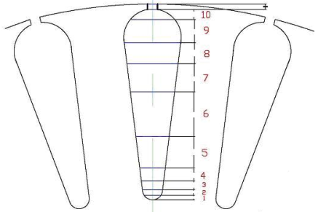

Fig 2.12. Conditional division of the slot of rotor into n - layers (n=11).

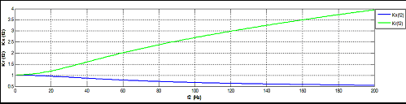

Fig 2.13. Dependences Kr and Kx on the current frequency in rotor f2

***Change in the inductance because of saturation of the machine***

Technical and economic indices during the development of engine determine the fact that with the nominalnoy load and the nominal flow the work occurs in the nonlinear section of the curve of magnetization of machine and therefore should be considered a change in the inductance because of saturation of machine. The leakage inductance of stator-rotor unit little depend on saturation of machine, since their fields are locked by air. Therefore we will examine the influence of saturation only on a change in the inductance of the chain of magnetization M, which nonlinearly depends on basic flux linkage  as shown ris.8.

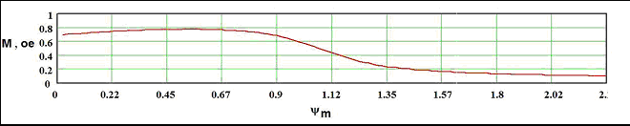

Fig 2.14. Dependence of the inductance of magnetization on 

***Basic indices of the generalized electrical machine in the dynamic behaviors in axes a.b.ch, ()***

For designing the electrical machines, which work in the dynamic behaviors, just as in those being steady, it is necessary to know the consumption of active and reactive power, and also the effectiveness of their conversion into the useful mechanical output [ 8 ]. For the comparison of models the following indices are selected.

A)  **for the starting regime:**

* Multiplicity of transient current in one of phases and impact moment with respect to the rated current and the moment, i.e. Ki = Imax / Inom, Km = Mmax / Mnom,
* Active R s and reactive Qs of the power, consumed by engine from the network in starting time, which are calculated by the formulas:

,  (2.112 33)

where 

 (2.113) instantaneous active and reactive power, T – the duration of starting regime.

* Power of eddy current losses

 (2.113)

where for the first version, for the second version

* Useful shaft horsepower in the starting regime:

, where, (2.114)

where - the mechanical and incremental losses

* Average values of the efficiencies - z and of power cos (ts) in starting time:

,  where  (2.115)

b) **for the steady-load condition**:

Useful shaft horsepower of engine, energy indices - z and cos (ts), loss in steel, current to the phase of stator A I and also time, spent by computer on the solution of this problem –.

For the demonstration of the work of models is selected engine RA 90 L 6 with the parameters:

 ,   ,   ,   ,   .

According to equations (11 -14) and (24-29) are comprised computer programs in the system M atlab. Fig. 10. presents the oscillograms of the currents of the phase of stator A, of phase of rotor, of internal torque and frequency of the rotation of rotor during launching of engine taking into account a change in the parameters of rotor Rr, and the inductances of the magnetizing outline M for two models.

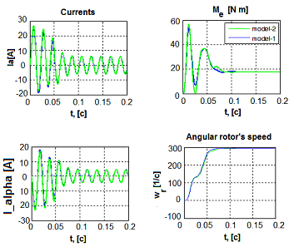

Fig 2.15. Results of Ra c of the even number of two versions of the model

Table 1 presents the results of the use of the enumerated above indices according to two models in the range of the frequencies: 25, 50 and 75 Hz. of characteristic were calculated with a change in the frequency according to the law  with, and with , moment on the shaft was supported by constant and equal to nominal.

Comparison of the indices of starting regime. Table. 1

|  |  |  |  |  |  |  |
| --- | --- | --- | --- | --- | --- | --- |
| ***f, [ Hz ]*** | **25** | | **50** | | **75** | |
| **1-4**  **the model** | **2 4**  **the model** | **1-4**  **the model** | **2-4**  **the model** | **1-4**  **the model** | **2-4**  **the model** |
| , [ o..e ] | 1,62 | 1,52 | 3,49 | 3,6 | 5,08 | 5,9 |
| , [ o..e ] | 3,057 | 3,33 | 5,94 | 6,239 | 8,57 | 9,1 |
| Ps, [ W ] | 1145,5 | 1224 | 3007,6 | 2938 | 5838 | 5385 |
| Qs, [ W ] | 1127,2 | 1457 | 3358 | 3470 | 6778 | 6404 |
| , [ W ] | 30,6 | 13,59 | 471,1 | 78,7 | 2094 | 193 |
| , [ % ] | 49,5 | 44 | 50 | 51 | 44 | 48 |
| , [ o..e ] | 0,71 | 0,64 | 0,66 | 0,64 | 0,65 | 0,64 |

C the alignment the indices of the steady-state regime. Table. 2

|  |  |  |  |  |  |  |
| --- | --- | --- | --- | --- | --- | --- |
| ***f, [ Hz ]*** | **25** | | **50** | | **75** | |
| **1-4**  **the model** | **2-4**  **the model** | **1-4**  **the model** | **2-4**  **the model** | **1-4**  **the model** | **2-4**  **the model** |
| , [ A ] | 3,63 | 4,64 | 3,85 | 3,9 | 4,69 | 3,9 |
| , [ % ] | 70,1 | 61 | 80,3 | 81,3 | 75 | 83 |
| , [ o..e ] | 0,8 | 0,68 | 0,74 | 0,72 | 0,66 | 0,72 |
| , [ W ] | 6,29 | 17,5 | 93,39 | 105,71 | 413,5 | 258,8 |
| ,[y/] | 44,97 | 43,1 | 99,08 | 99,07 | 151,6 | 151,9 |
| P 2 , [ W ] | 677,86 | 650,59 | 1515,4 | 1519 | 2333 | 2339 |
| , [ c ] | 0,12 | 3,42 | 0,24 | 6,77 | 0,17 | 10,2 |

Mathematical model is represented in two versions: the first version with six by differential equations (DU), of the second with nine times DU the comparison of the results of calculating the starting and steady-state regimes showed a sufficient for the analysis convergence of results on these two models. However, losses into steel in starting time, models calculated according to the first version considerably exceed the analogous losses of the second version. From other side the computer time of calculation according to the second version ten times exceeds the time of the calculation of the first version. On us view, more adequately describes transient processes the mathematical model of the second version. This must be considered during the selection of models for developing the high speed systems of vector control of adjustable induction motors.

**Conclusions**

In the proposed structure of mathematical models, describing work system PCh- hell, that consider the effect of current displacement in the conductors of the rotor winding, saturation of magnetic circuit, law of control of invektorom SHIM;

The developed procedures and the programs of the calculation of the transient operating modes make it possible to in detail investigate the influence of the form of input voltage AD and the parameters AD on its energy indices at the nourishment from the frequency converter.

As a result of the comparison of different criteria of optimality, on the basis of the carried out optimization calculations, are given the recommendations regarding the selection of construction AD with the short-circuited rotor, that work together with the static converters.

Is developed the mathematical model of the frequency adjustable engine in the axes (a.b.ch, (bv)), in which the losses in steel are considered, and the influence of saturation and current displacement is considered with the aid of coefficients of Kmu, K r and Kx. Are represented the dependences of the effective resistance of the magnetizing outline of equivalent to losses in steel on the frequency of reversal of polarity.